April 12, 2021

The Honorable Thomas Vilsack

Secretary

U.S. Department of Agriculture

1400 Independence Ave., S.W.

Washington, DC 20250

Dear Secretary Vilsack:

We write today to share with you our selections for the USDA position of Farm Service Agency (FSA) Executive Director in Maine, as well as the Advisory Committee positions that provide guidance for the Director.

Sherry Hamel is an extremely qualified candidate for the position of FSA State Executive Director.  Not only has she ably filled the role twice on an interim basis, her history within the agency has made her extremely familiar with the programs and requirements for the job.  She has a demonstrated concern for the staff, and has been invested in making sure that they have the tools and support that they need for performing the necessary duties of the agency.  Maine, especially its heritage industries like agriculture, has a storied tradition of rugged individualism, but Ms. Hamel has identified some areas for outreach which will help to grow the influence of FSA within Maine, strengthening the programs in the process.

The influence and reach of the Executive Director is enhanced not just by their expertise and that of their staff, but by their ability to utilize input from their advisory committee.  We have selected the following individuals to assist Ms. Hamel in these efforts, collectively, their backgrounds represent a good cross-section of interest groups within the industry:

Annie Allen, Holden

Penny Jordan, Scarborough

Ward McLaughlin, Mars Hill

Michael Dennet, Jefferson

Aaron Carroll, Limerick

Thank you for your expeditious consideration of these recommendations.  Please contact us with any questions about these candidates, or direct your staff to reach out to Jesse Connolly ([Jesse.Connolly@mail.house.gov](mailto:Jesse.Connolly@mail.house.gov)), Sharon Campbell ([Sharon_Campbell@king.senate.gov](mailto:Sharon_Campbell@king.senate.gov)) or Barbara Hayslett ([Barbara.Hayslett@mail.house.gov](mailto:Barbara.Hayslett@mail.house.gov)).

Sincerely,

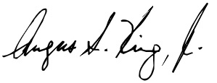 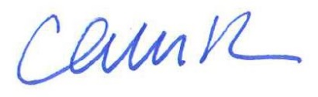

Angus S. King, Jr. Chellie Pingree

United States Senator Member of Congress

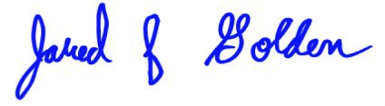

Jared F. Golden

Member of Congress