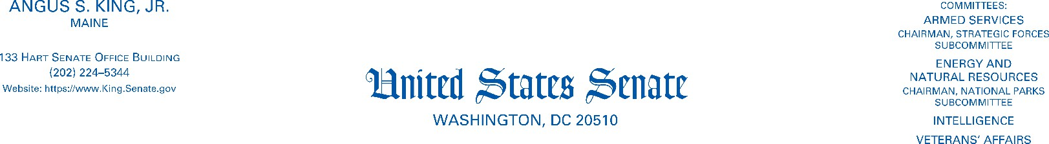

February 8, 2024

The Honorable Pete Buttigieg

U.S. Department of Transportation 1200 New Jersey Avenue, SE Washington, D.C. 20590

Dear Secretary Buttigieg,

I write today to ensure that the Department of Transportation (DOT), with you at the wheel, is not driving distracted in our nation’s quest for safer streets. The United States is unique among advanced countries for failing to decrease traffic deaths in the past twenty years—and in fact, has seen them increase. As a cosponsor of the Road to Zero resolution in the Senate, I believe that implementing proven measures to reduce traffic deaths should be among the foremost responsibilities of the DOT. However, that does not include a ban on signs which through humor or wit attempt to give their messages a bit of fresh tread; I hope we can avoid a head-on collision on this.

There’s a mile-long backup of traffic safety issues that the DOT should address, including distracted driving, impaired driving, roads and highways which prioritize throughput and speed over safety, and vehicles which grow in size and weight each year, and manufacturers charging premiums for what should be basic safety features. I also respect and appreciate the hard work of the civil servants who compile and update the Manual of Uniform Traffic Control Devices (MUTCD), and recognize the importance of ensuring continuity and predictability in messages which drivers rely on to navigate safely. However, both researchers and highway officials in many states have found value in messages which break through the traffic jam of information.

At risk of not staying in my lane, I’d also call to your attention that the last few years’ fleets of new vehicles contain myriad multimedia surfaces and screens—showing entertainment or live feeds from on-vehicle cameras. Given that drivers are now navigating around “Bluey” re-runs, abrupt lane change alerts and rear-door camera views, your concern over a dozen well-intended words on a road sign seems off-course.

It’s hard for me to believe that the examples of traffic safety messages included in the MUTCD—“Unbuckled seat belts fine + points” and “Impaired drivers lose license + jail”—would be easier to remember than their more popular equivalents—“Click it or ticket” and “Drive sober or get pulled over.”

I ask that you respond to the two following questions:

1. Will you commit that the Department of Transportation, and subagencies therein, will not sanction or discourage, formally or informally, states which use humor or pop culture references while conveying an otherwise appropriate safety message?



Page 2

1. Will you commit that the Department of Transportation, and subagencies therein, will not withhold or threaten to withhold funding to states which use humor or pop culture references while conveying an otherwise appropriate safety message?

I look forward to your response. Please do not hesitate to be in touch should you have any concerns about the road ahead.

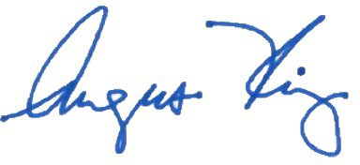Sincerely,

ANGUS S. KING, JR.

United States Senator